

ECAD Teamcenter Integration   
User Guide  
  
STW-00322  
Revision 01

Abstract: This user guide describes the use of Siemen’s EDA Gateway as the integration tool between Cadence Allegro and Siemen’s Teamcenter.

Table of Contents

1 Revision 4

2 Introduction 4

3 Installing the EDA Gateway application 4

4 Staging Folders 5

5 Links to Standard Work 6

6 Mapping Teamcenter properties to Schematic and PWB drawing formats 6

7 EDA Gateway Checklist 6

8 Prepare Project Folder 7

8.1 Overview 7

8.2 Folder Structure 7

9 Preparing Schematic and PWB Files 9

9.1 Schematic DSN file, no Variants 9

9.2 Schematic DSN file, with Variants 9

9.3 PWB BRD file 10

9.4 Derived Data (Outputs) 10

10 Allegro Teamcenter Menu Items 11

11 Overview 13

12 Running Teamcenter from Design Entry CIS (OrCAD Schematic) 14

12.1 Schematic – Save as 14

12.2 Schematic – Save As, Edit names 14

12.3 Schematic, Save as – Edit Details 15

12.4 Schematic, Save as – Bom Compare 16

12.5 Schematic - Check-Out 19

12.6 Rename dsn and brd files, optional but recommended 19

12.7 Schematic - Check in 20

12.8 Schematic - Save 20

12.9 Schematic - Open 20

12.10 Schematic – Design info 20

13 Substitute Parts 22

13.1 Schematic - Structure manager 22

14 Running Teamcenter from Allegro PCB Venture 23

14.1 PWB – Save as 23

14.2 PWB – Check-Out 24

14.3 PWB – Attribute mapping to Allegro 24

14.4 PWB – Check-In 25

14.5 PWB – Save 25

14.6 PWB – Save 26

14.7 Teamcenter Pseudo folders 26

14.8 Consumer Guide, overview 27

14.9 Consumer Guide, downloading pdf and Zip file datasets 28

# Revision

|  |  |  |  |  |
| --- | --- | --- | --- | --- |
| REV | REF | DESCRIPTION OF CHANGE | AUTHOR | DATE |
| 1.0 |  | Initial Release | C Simmonds | 2023-02-27 |
|  |  |  |  |  |

# Introduction

This guide describes the use of Siemen’s EDA Gateway as the integration tool between Cadence Allegro and Siemen’s Teamcenter. A working knowledge of both Teamcenter and Cadence Allegro is assumed.

The EDA Gateway is the bridge between our Cadence Allegro CAD tools and the Teamcenter A&D PLM system.

# Installing the EDA Gateway application

The EDA Gateway application (UAT) is available from Workspace ONE*, after installation new desktop short-cuts will have been created. We are only concerned with the Teamcenter, Schematic and PWB icons as shown, the others may be ignored or deleted.

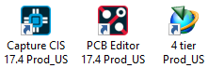

*If not found on Workspace ONE it may be installed directly from L:\ECAD\GLOBAL\TC13_Build\4-Tier_Prod.zip.

# Staging Folders

The Staging Folder is where EDA Gateway exports the Schematic and PWB datasets to when opening from Teamcenter. This may be configured to either be on your local PC else on a shared secure fileserver.

Change the location of your Staging Folder by editing the **TCEDAClient.properties** file, this can be found here: **C:\Siemens\Tc13\4-Tier_Prod\TeamcenterEDA_5.2.5**

The location of the Staging Folders is set on line 94 (this may change depending on other setting that may have been made, but is clearly marked in the file as “EDA File System”). In the example below the default value of **#StagingDir=C\:\\eda_gateway_stage\\tc5_acceptance** has been commented (with #) and a new line added specifying a shared secure fileserver instead. **StagingDir=L\:\\ecad\\_site\\TC_WIP.**

Having the Staging Directory on a secure file server has the benefit that typically these file servers are continually backed up and so in the event of you own machine suffering a disk failure your data is secure. This comes at a cost though, as fileservers may be slower to respond than when using your own local drive.

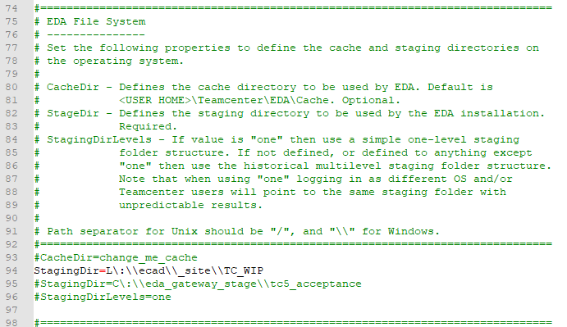

The Staging Directory is used as the repository for data-sets opened from Teamcenter. Unlike our NX Teamcenter integration where files are opened directly from Teamcenter, the eCAD integration through EDA Gateway works differently, when opening a file from Teamcenter the schematic and/or PWB data-set is extracted from Teamcenter and copied to a folder underneath the Staging Directory. You then continue to work in Allegro Design Entry CIS (schematic tool) or Allegro Venture (PWB tool) in the same way as you would normally. It is acceptable to save directly to your Staging Directory during the course of the design process, only saving and/or checking files back into Teamcenter if the items are to be Statused or released.

BOM. The bom is extracted from the schematic dsn file, saving the schematic to Teamcenter gives you the option of generating the bom, so if a bom is required in Teamcenter to drive demand else for an advance bom the schematic should be saved to Teamcenter and thus the bom generated.

The image below shows the data model in Teamcenter, data-sets as indicated are two Zip files, the schematic containing all files and folders contained n the Sch folder, and the PWB the Zipped up contents of the Allegro folder.

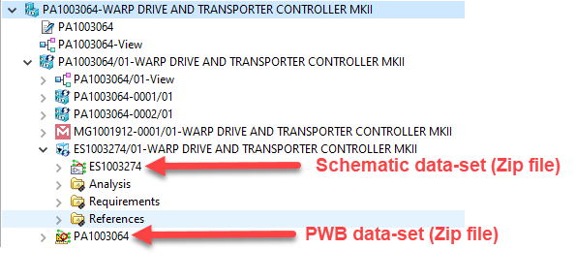

# Links to Standard Work

To be added.

# Mapping Teamcenter properties to Schematic and PWB drawing formats

To be added.

# EDA Gateway Checklist

To be added.

# Prepare Project Folder

## Overview

The Project Folder should adhere to a specific structure with regards to the Schematic and PWB datasets and (derived) output files.

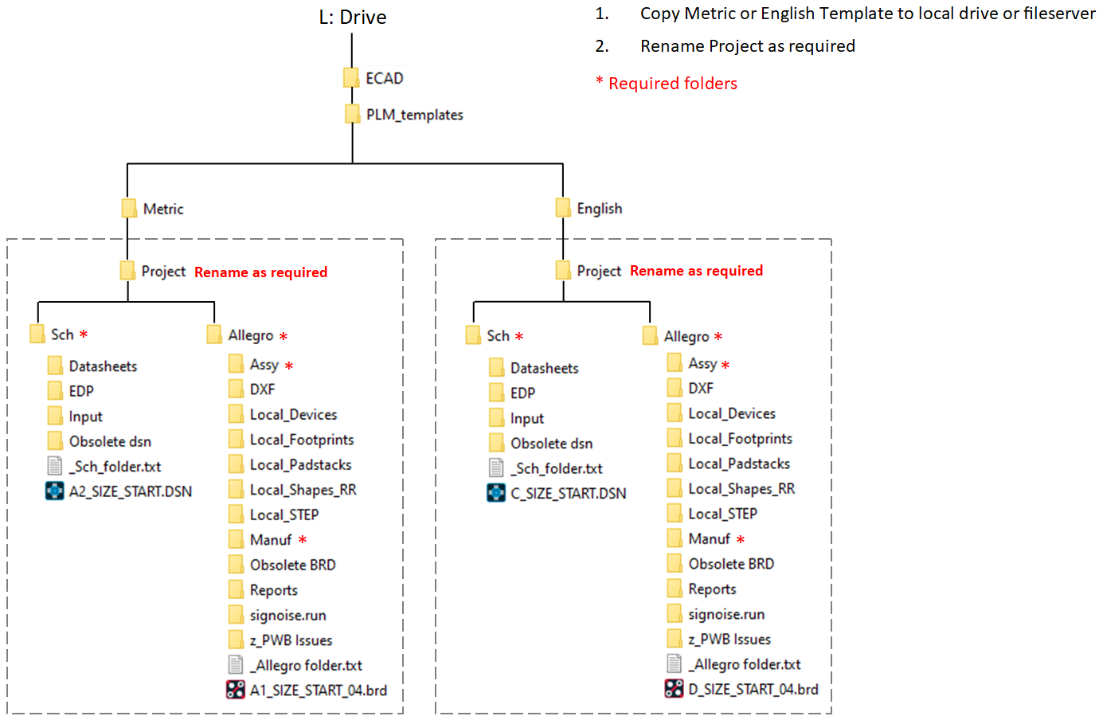

## Folder Structure

Before Checking-In your Schematic or PWB to Teamcenter for the first time a Project folder should be created on your local machine or a shared fileserver. This Project folder must contain at a minimum, two subfolders, Sch and Allegro, which contain a single dsn and brd file respectively (if more than one dsn file is required, for example a reference design, then this should be stored in in a subfolder of Sch or Allegro). Example:



Expanded:

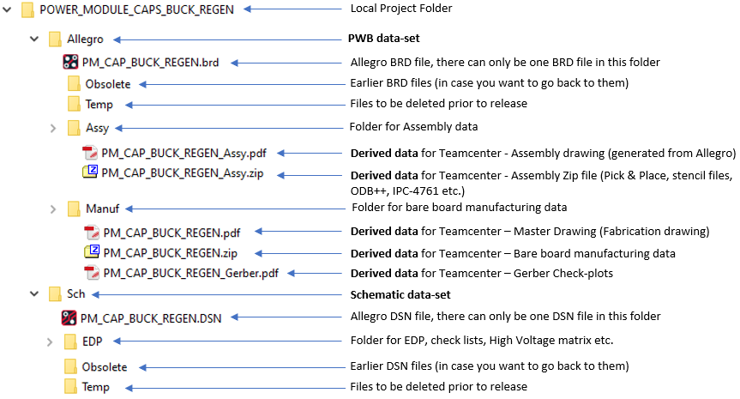

Notes:

EVERYTHING under the Allegro and Schematic folders are stored in Teamcenter in two Zip files.

* There must only be one DSN, OPJ and BRD file per project (directly under the Sch and Allegro folders)
* PWB output files (derived data) must be correctly named and in the appropriate folder – List names
* Automatically derived outputs are limited to the Schematic drawing PDF files, if your local Allegro environment is so configured these will be smart PDFs. The schematic BOM is automatically generated from the dsn file each time it is checked-In or saved. Schematics with properly defined variants will produce as many PDF drawings and BOMs as there are variants
* There is a template folder structure available from L:\ECAD\Global\PLM_templates
* EDA Gate requires the Sch and Allegro folders are directory under the Project folder and at the same level. This may be different from what you are used to, where the schematic dsn file was under the Project folder and the Allegro folder was under this. Warning, several configurations may need to be changed to match this!

Best practice would be to run your initial “Save As” from the empty template folder, as generally the purpose of the first “Save As” is to assign numbers for the PCA (Printed Circuit Assembly), Schematic and PWB and establish the data-model (item relationships). Having data in the Sch and Allegro folders just slows down the process as the complete Sch and PWB folders are Zipped up and written to Teamcenter.

Once the initial “Save As” has been run there is no reason o continually save your schematic and/or PWB util is required to be Statused (released) unless you need the bom to be on Teamcenter, which is optionally loaded each time the schematic is saved or checked-in.

# Preparing Schematic and PWB Files

Historically the schematic dsn and PWB brd files would be named per the Moog drawing number generated by the Automatic Number Sign-out utility, with A&D PLM it is Teamcenter that allocates these (referred to as item IDs). Because there must be at least a dsn file available before initial Saving to Teamcenter, the dsn file should be named descriptively instead, for example, Processor, GateDrive, PowerSupply etc. Once the initial “Save as” command has been run from Design Entry CIS and the item IDs generated, the dsn and brd files can be renamed if desired, although this is not essential as once stored in Teamcenter the dsn and brd files are related to their respective item IDs so do not need to be named thus.

## Schematic DSN file, no Variants

The BOM is extracted directly from the schematic dsn file, so this should be accurate, and only contain released parts (that exist as items in Teamcenter). Parts not required on the BOM (mounting holes, fiducial marks etc.) should be given the property BOM_IGNORE = true.

For a schematic that has no variants it should be set up as a single variant design, this keeps the Teamcenter data structure consistent between variant and non-variant designs, it also allows single variant designs to be expanded to multiple variant designs without having to generate (Save as) a new item. Name the Variant 0001.

Variants should be managed through Part Manager, a single Variant named 0001. The template dsn file will have a single Variant configured, this prevents having to manage variant and non-variants differently (a single Variant is effectively a non-variant design, as only one bom is created.

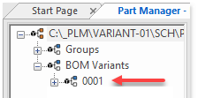

Once saved to Teamcenter the schematic will be named ESXXXXXXX with an initial revision of 01.

## Schematic DSN file, with Variants

The BOM is extracted directly from the schematic dsn file, so this should be accurate, and only contain released parts (that exist as items in Teamcenter).

Variants should be managed through Part Manager, with each Variant named 0001, 00002 etc. The template dsn file will have a single Variant configured, this prevents having to manage variant and non-variants differently (a single Variant is effectively a non-variant design, as only one bom is created.

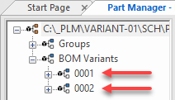

Parts not required to on the BOM (mounting holes, fiducial marks etc.) should be given the property BOM_IGNORE = true.

Once saved to Teamcenter the schematic will be named ESXXXXXXX with an initial revision of 01 (XXXXXXX is a sequential number assigned by Teamcenter at the time of saving).

## PWB BRD file

Once saved to Teamcenter the PWB item will be named MGXXXXXXX-0001 with an initial revision of 01.

## Derived Data (Outputs)

Derived data refers to files extracted/exported from Allegro Design Entry CIS and Allegro Venture that are to be available from Teamcenter. The schematic drawing(s) are created automatically each time the schematic item is saved to Teamcenter (providing the box is checked), this makes PDFs available to colleagues without the need for them to generate from Allegro Design Entry CIS. If Variants have been correctly set up in Part Manager there will be as many schematic PDFs produced as there are variants. The variant schematics retain the same item ID and are differentiated by their associated variant number; -0001, 0002 etc..

Derived data is not automatically generated from Allegro Venture PCB, these data include PDF drawings of the Master and Assembly drawings, Zip files of the manufacturing Gerber and drill data, pick and place files, IPC-2581, ODB++ files etc. These should be validated before posting on Teamcenter, and are created directly from the Allegro tool itself and not part of the “Save as”, “Save” or “Check-in” commands.

List of Derived Outputs that will be available from Teamcenter:

|  |  |  |
| --- | --- | --- |
| Folder | Specification | Description |
| Allegro\Manuf\ | *_Gerber.PDF | Check plot of each Film/Gerber layer |
| Allegro\Manuf\ | *_MD.PDF | Master Drawing |
| Allegro\Manuf\ | *_MP.PDF | Master Pattern (optional) |
| Allegro\Manuf\ | *_Man.ZIP | Data required to fabricate bare PWB (Gerber, ODB++,IPC-2581 etc.) |
| Allegro\Assy\ | *_ASSY.ZIP | Data required to populate PWB (ODB++,IPC-2581 STP, Pick & Place etc.) |

# Allegro Teamcenter Menu Items

A Teamcenter menu is available from both Design Entry CIS (OrCAD schematic) and Allegro Venture PCB.

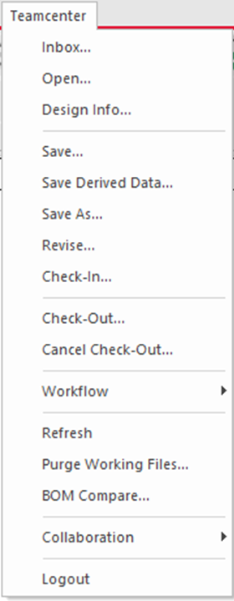

* **Inbox:** not used (may be used in future workflows)
* **Open:** open exiting Schematic or PWB datasets
* **Design Info:** lists PCA & Schematic numbers, check-in/out status, working folder etc.
* **Save:** save dataset to Teamcenter (dataset Zip file is Schematic or Allegro folder and contents, including any sub-folders). Checks-in and Checks-out so the user may continue updating the schematic or PWB
* **Save Derived Data:** creates and saves schematic drawing PDF(s) to Teamcenter, saves existing PWB datasets to Teamcenter
* **Save As:** typically run at the start of a project, creates PCA structure and assigns item IDs to PCA, schematic, PWB and variant(s)
* **Revise:** not used (seems to do the same as Save”, requires investigation)
* **Check-In:** checks-in schematic or PWB items, datasets and derived data if checked. Once Checked-in the user must Check-out again before making further updates to the schematic or PWB
* **Check-Out:** checks-out schematic or PWB items, datasets and derived data if checked
* **Cancel Check-Out:** cancels check-out
* **Workflow:** not used, workflows are run directly from Teamcenter
* **Refresh:** loads the latest schematic or PWB from Teamcenter if it has been updated outside of the current users local staging folder
* **Purge working files:** deletes local copies of schematic or PWB datasets – use with care
* **BOM Compare:** compares the BOM extracted from the schematic with the current Teamcenter version and generates a report
* **Collaboration:** not used
* **Logout:** logs out of Teamcenter

# Overview

The image below shows the work-flow between the CAD tools, EDA Gateway and Teamcenter.

# Running Teamcenter from Design Entry CIS (OrCAD Schematic)

## Schematic – Save as

From Teamcenter menu, select “Save As”. After a while a screen as below will appear. Expand the items so the contents may be seen. Check the items you wish to send to Teamcenter, “Viewable” should be unchecked as Moog does not have a license for this (Allegro Teamcenter viewer) confirm “Check-In” is checked as shown. (keep incrementing for as many variants as there are). Select the name of the PCA, Schematic and PWB items in turn and change to the name that should be displayed in the drawing title blocks. For each of these three items also select the Details button and update the CAGE code etc.

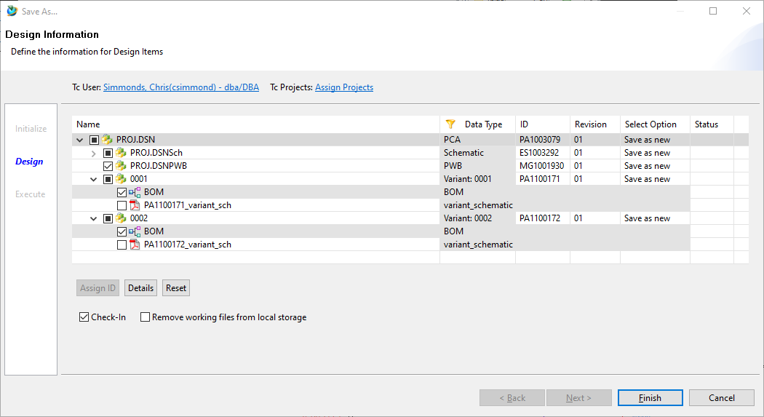

## Schematic – Save As, Edit names

Rename the PCA, Schematic and PWB items to reflect the name you wish to appear on the title block. Do not include either the SCH or PWB prefix, as these are added automatically when transferring properties back from Teamcenter to Allegro.

Rename the Variant(s) to match the top level PA# and dash number(s)

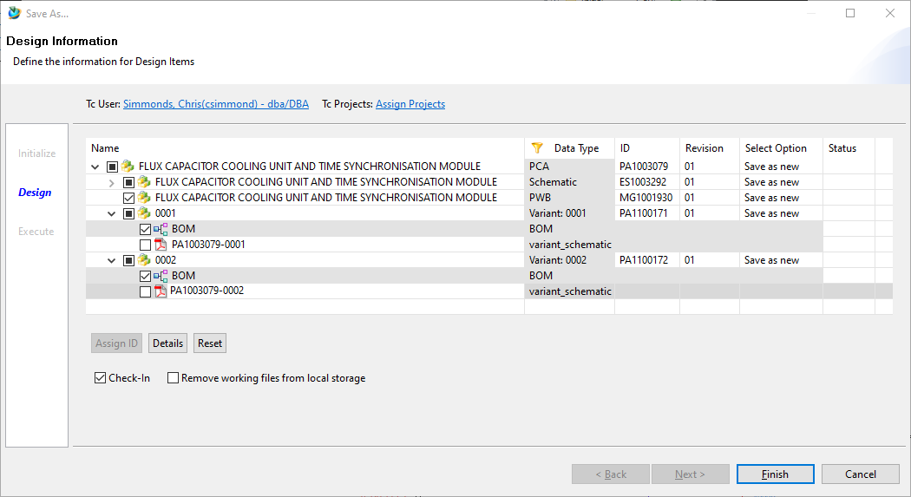

## Schematic, Save as – Edit Details

From the same “Save As” dialogue screen select the PCA item and click the “Details” button. A PCA Details window opens, select the “Additional Item Information” tab and scroll to the “Original Operating Group” and select the applicable value (Space and Defense or Aircraft), then “Original Site”, upon selection the CAE code and Original Legal Company Name” will automatically populate.

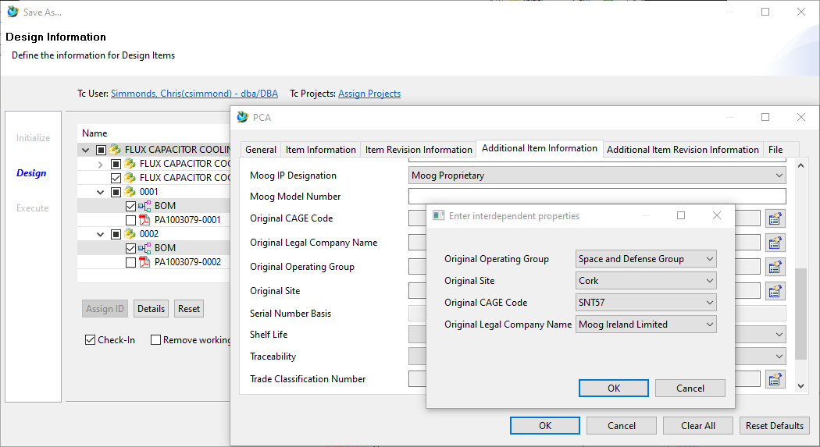

Click OK then scroll down up to select “Legal IP Designation” and down to select “Trade Jurisdiction” and Trade Classification Number”

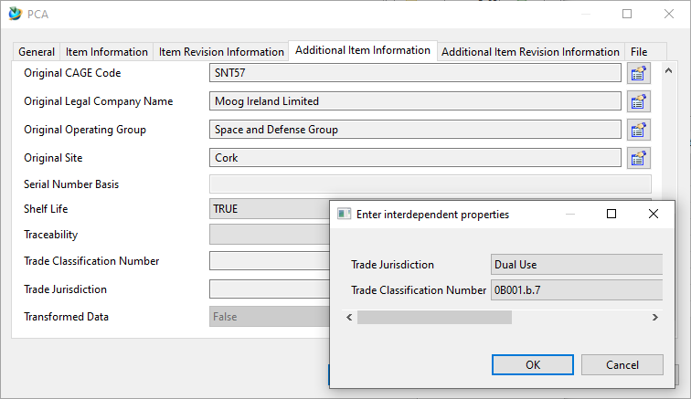

Click OK and repeat for Schematic and PWB items.

Note, “Additional Item Information” can only be added at the time of initial “Save As”, if edits are required after this they must be made through the Teamcenter client under edit Properties.

## Schematic, Save as – Bom Compare

Once the item names have been changed and the “Additional Item Information” entered, check or uncheck bom and pdf items. At the beginning of a project there is probably no need to generate either the schematic pdf files or the bom, in this example we are generating the bom but not the schematic pdfs.

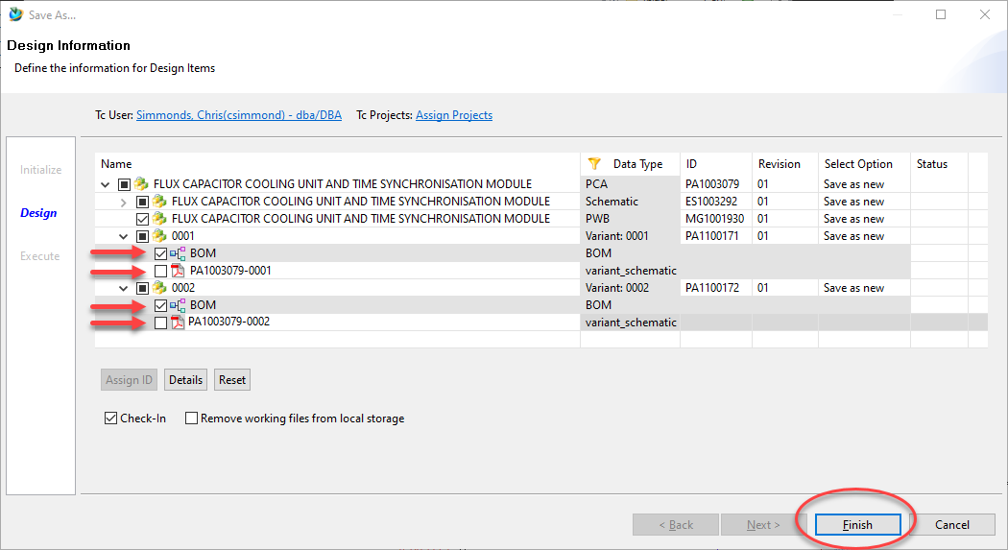

After a short while the BOM compare window will open, in the example below you can see variant -0001 is a fully populated PWB, whereas variant -0002 does not have R1, R2 and C1 fitted. Review as required and click OK.

Note, parts reported as “missing” are not found on Teamcenter, and the resultant BOM generated in Teamcenter Structure Manager will be incomplete! These missing items should be added to Teamcenter and the BOM regenerated.

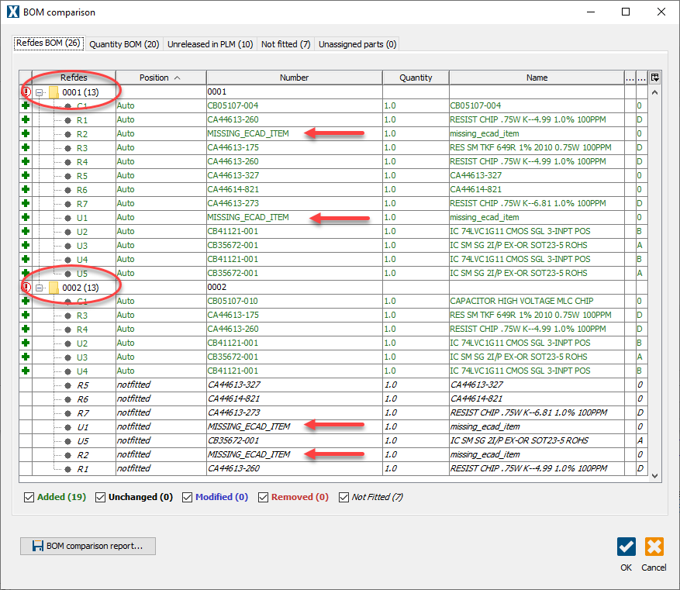

Click OK.

A new screen should appear showing the dataset was successfully created.

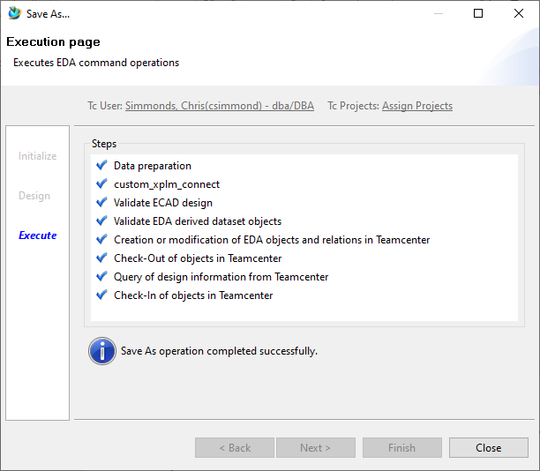

This confirms the schematic dsn file has been checked into Teamcenter. Schematic PDF drawing files and BOM will also be checked-in if they were selected.

## Schematic - Check-Out

Checking-out the schematic also updates the mapped title block attributes. This includes the schematic revision, item ID (drawing number), PWB item ID and PCA variants, IP Classification and Trade Jurisdiction.

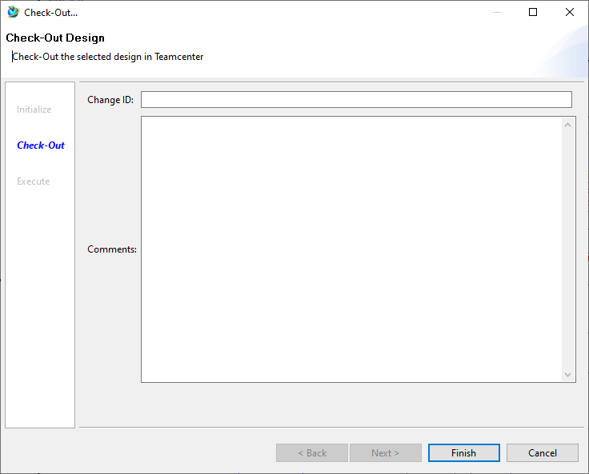

Schematic drawing format after Checking-out:

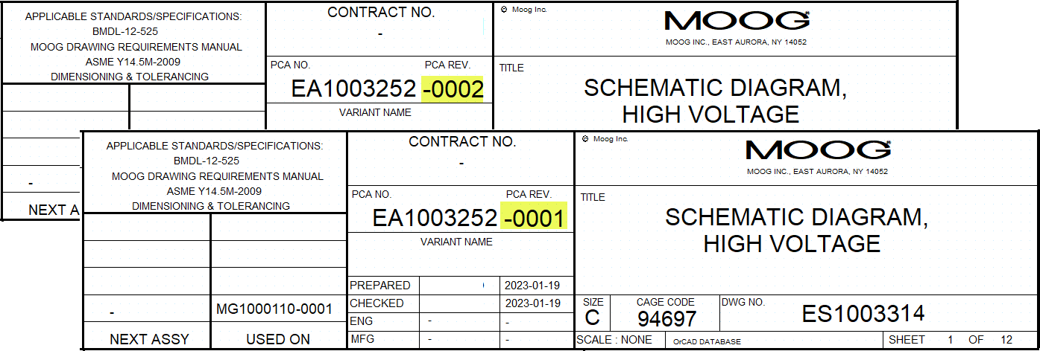

## Rename dsn and brd files, optional but recommended

Once the project has been saved to Teamcenter the schematic and PWB have been assigned item IDs, rename the original dsn and brd files their respective item IDs.

1. Make a note of the schematic and PWB item IDs (ESXXXXXXX and MGXXXXXXX)
2. Navigate to the schematic folder (right-click dsn and select “Open File Location”)
3. From OrCAD schematic Close current dsn
4. From Explorer delete project file *.opj
5. From Explorer rename <current>.dsn to ES <item ID><item rev>.dsn
6. From OrCAD schematic open renamed dsn file, this will create a new project (opj file which is required by EDA Gateway).
7. Save or Check-in the schematic, will overwrite the existing schematic data-set with the newly renamed dsn file, which now carries the ES# assigned by Teamcenter
8. From Explorer navigate to Allegro folder and rename <current>.brd to MG <item ID>

## Schematic - Check in

This saves and Checks-in the schematic dataset and any selected BOM(s) and drawing(s). Subsequent changes made to the schematic cannot be Saved until it has been checked-out again.

Checking “Remove working files from local storage” will delete your original project folder from your local machine or fileserver. When subsequently opening from Teamcenter the project folder will be re-created in the configured staging Directory (running “Design Info” will reveal the location). Staging Directory may be configured by editing the TCEDAClient.properties file, this can be found here: C:\Siemens\Tc13\4-Tier_Prod\TeamcenterEDA_5.2.5.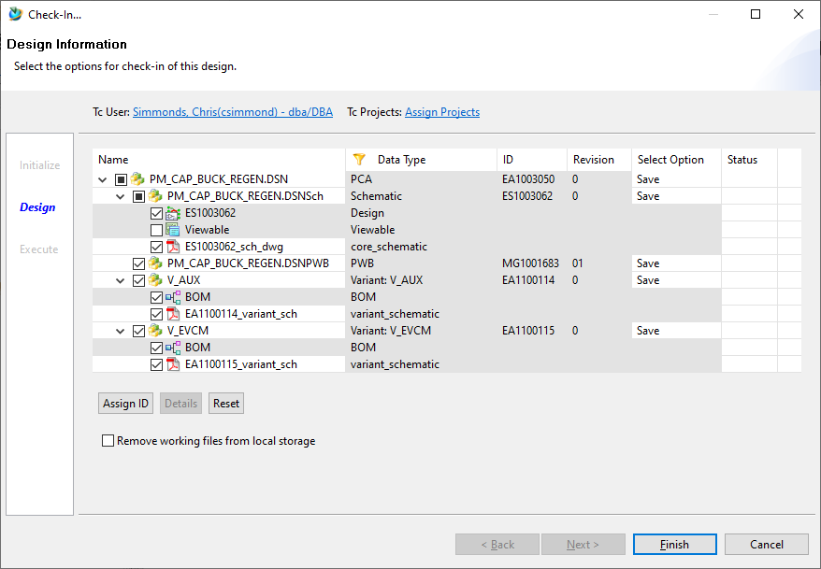

## Schematic - Save

This saves, Checks-in and Checks-out the schematic dataset and any selected BOM(s) and drawing(s).

## Schematic - Open

Opens an existing schematic from Teamcenter. A browser windows opens allowing you to select the PA number containing the schematic you wish to open,

## Schematic – Design info

Displays information about the schematic.

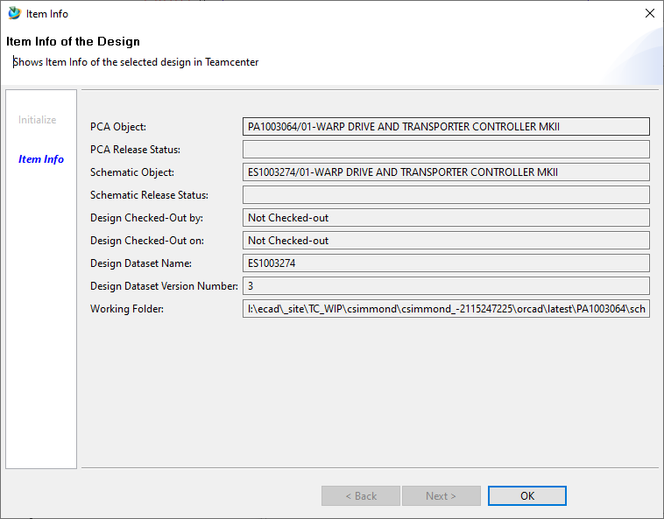

Question probably for Brian DeShazer, can the PWB item be released independent to the PCA? The NX model falls under the PCA and not released at the same time.

# Substitute Parts

## Schematic - Structure manager

To add substitute parts to BOMs extracted from the schematic, open Structure Manager and select the item to add a substitute to and double click the “Substitute” icon. Add the item ID of the substitute part to be added and click OK.

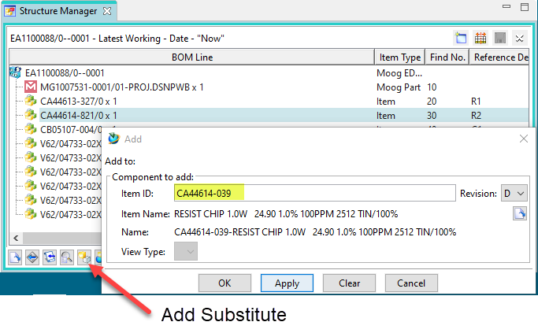

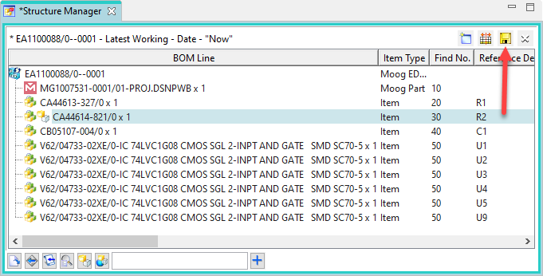

Save the revised Structure. Subsequent updates to the BOM through the Teamcenter menu “Save” or “Check-in” retain any substitutions made.

# Running Teamcenter from Allegro PCB Venture

## PWB – Save as

Always uncheck “Viewable”, this requires a Teamcenter viewer license that Moog does not subscribe to.

Check derived outputs as required*

Select “Check-In”

Do not check “Remove working files from local storage” with the first save.

*Only check derived outputs as they are required, with the first “Save as” typically none of these are available at the start of a design.

Important! Rename the derived outputs per the PWB MG# (by default they adopt the PA#).

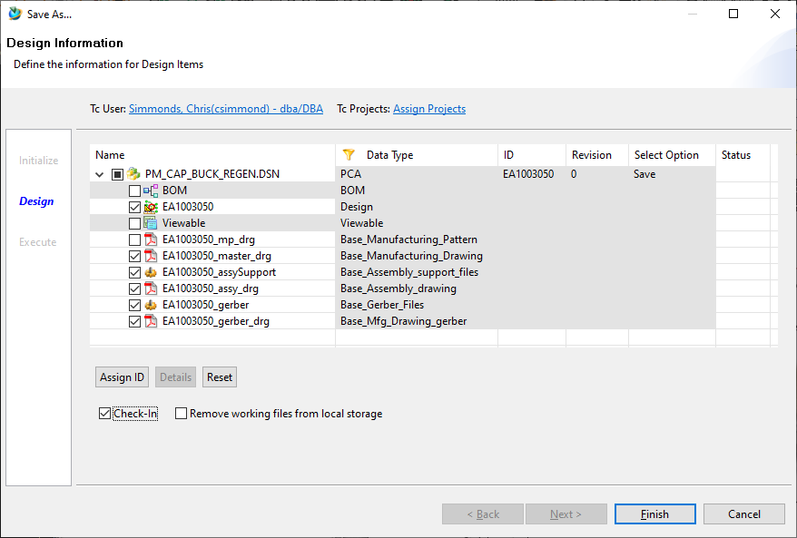

If the “ID” is incorrect double click “Save as new” under “Select Option”, and then change to “Select Existing”. A window will display allowing you to select an existing PCA.

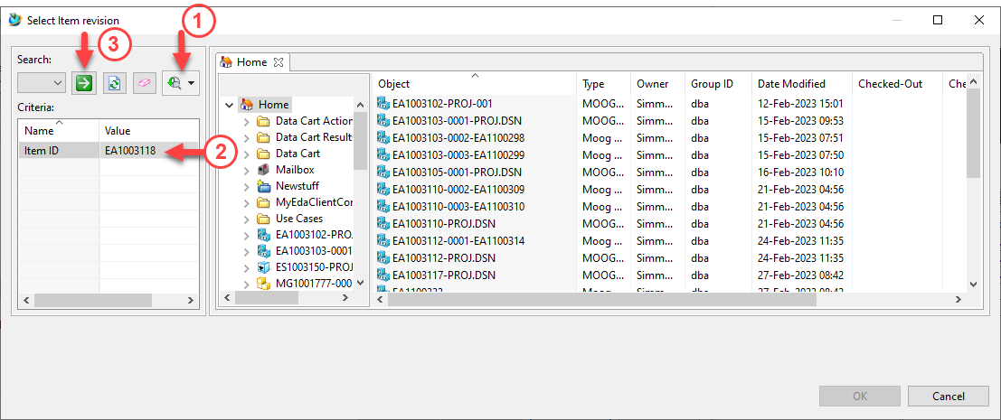

## PWB – Check-Out

Immediately following a “Save as” run “Check out”, this will map Teamcenter attributes to Allegro properties which in turn can populate the Master Drawing title block.

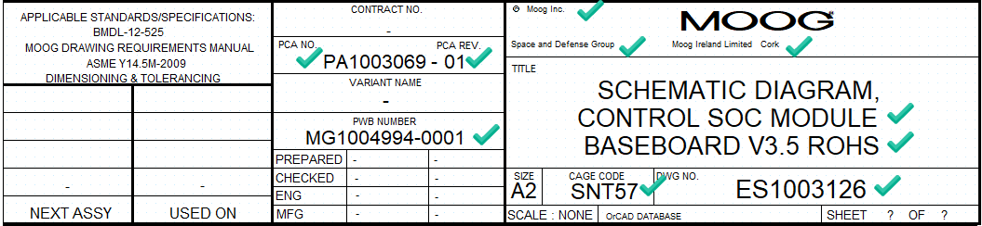

## PWB – Attribute mapping to Allegro

Unlike the schematic tool, Allegro PCB databases (brd files) do not have default properties to map to, these have been added to the brd file templates available from L:\ECAD\Global\PLM_templates. If you are using an existing brd file that does not have these properties added, then they must be added before they can be mapped from Teamcenter. The Allegro properties are loaded to the drawing format title block by means of a custom Skill file. This is available under the Allegro PLM menu (may not have been implemented at the time of writing).

## PWB – Check-In

Check in copies your project folder staging directory to the Teamcenter item revision dataset. This Zipped dataset comprises the entire folder structure under the top-level Allegro folder.

As with “Save as” always uncheck “Viewable” and select derived data as required.

Checking “Remove working files from local storage” will delete your original project folder from your local machine or fileserver. When subsequently opening from Teamcenter the project folder will be re-created in the configured staging Directory (running “Design Info” will reveal the location).

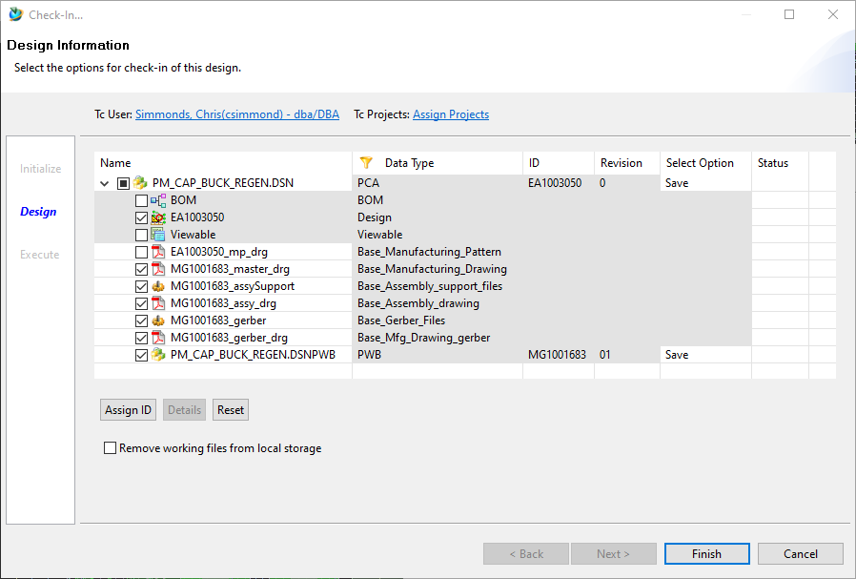

## PWB – Save

This saves, Checks-in and Checks-out the PWB dataset and any selected datasets and drawing(s). Because the Save command also Checks-out the PWB, the user may continue updating it.



## PWB – Save

This saves, Checks-in and Checks-out the PWB dataset and any selected datasets and drawing(s).

## Teamcenter Pseudo folders

For definition of pseudo folders and their item types refer to STW-00321.

## Consumer Guide, overview

Once a PWB design is complete, viewing it on Teamcenter will look something like this.

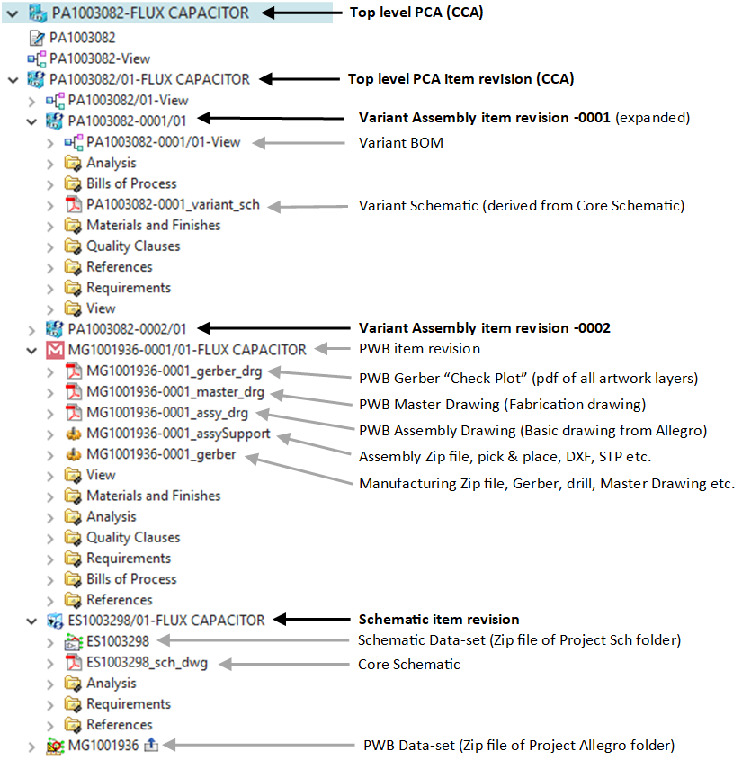

All related PWB data is under the top level PA “Container”. There may also be NX data-sets, as the assembly model should be named per the Variant Assembly, in this example there are two variants, so two NX assemblies are required, PA1003081-0001 and PA1003081-0002.

When searching for PWB data in Teamcenter the PA number should be searched for, this PA number is shown on both schematic and PWB drawing title blocks. If the PA number is not known then searching on either the schematic ES# or PWB MG# will show the relevant item. If you have the schematic ES#, then “impact Analysis, Where Referenced” will show the top level Container item:

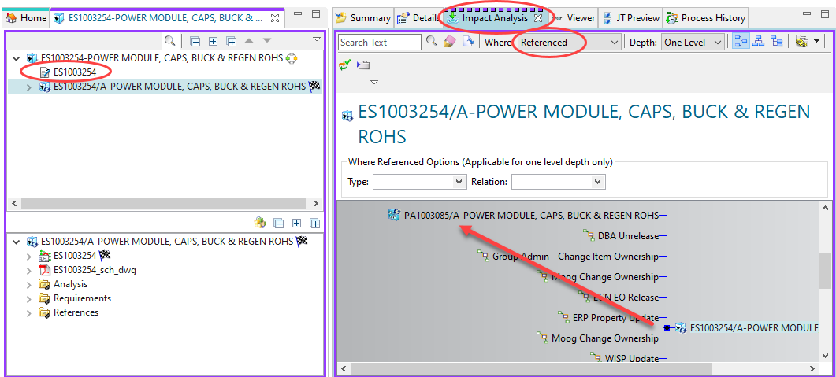

If you have the PWB#, then “impact Analysis, Where Used” will show the top level Container item:

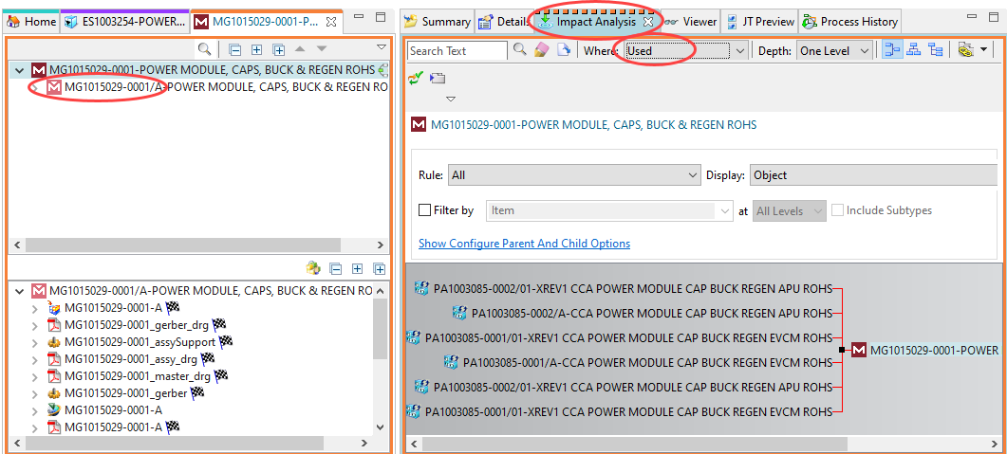

## Consumer Guide, downloading pdf and Zip file datasets

The datasets may be downloaded as required.

Both the pdf and Zip files will open by double clicking.

Pdf files, these open in your default pdf browser, the Zip files open up the Zip application, from where you can save the contents.

To download the file:

Right-click then select “Named References”. A dialogue window will open, select the Zip file and then click the Download button. Navigate to the location where you wish to save the Zip file. The FILENAME WILL BE INCORRECT as it references the PCA#, whereas the Zip file selected should per the PWB MG#. Edit the File name! In future releases this should not be required.

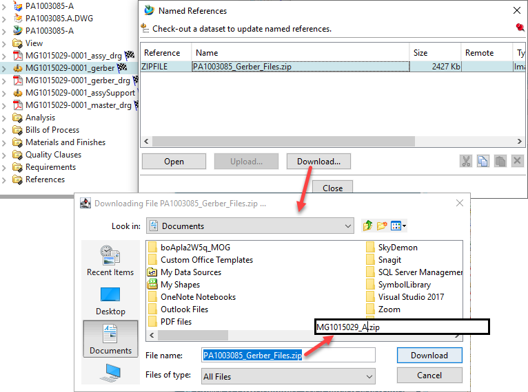

Note, in the interest of data singularity, files should only downloaded if they are to sent to external contractors for fabrication or assembly. Once items are released Teamcenter should always be considered to contain the master files.